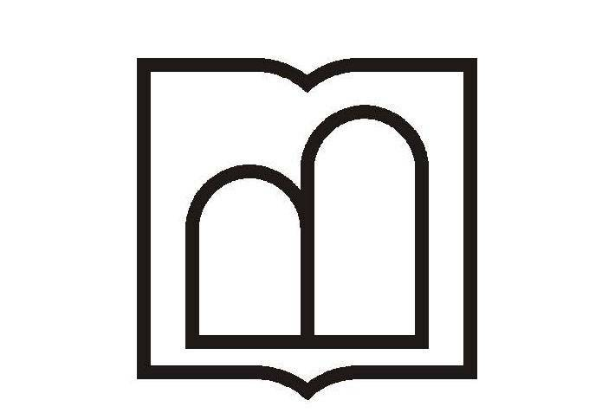

Ministry of Health and Medical Education
Ardabil University of Medical Sciences

APPLICATION FORM

Please fill out this form and send it together with the necessary documents*. Incomplete forms will not be processed.

A) PERSONAL DETAILS
Sex | Male Female
First Name
Middle Name
Last Name
Date of Birth | Day: Month: Year:
Place of Birth | City: Country:
Marital Status | Single Married
Nationality
Passport Information | Passport No: Date of Expire:  Date of Issue: Place of Issue:
Corresponding  Address | Flat: No: Street: City:  Province/State: Postal/zip Code: Country:
Telephone No
Fax No
E-mail

B) EDUCATIONAL INFORMATION
1. All schools/ Educational Institutions attended in chronological order
Degree | School/University | Field of Study | City/Country | Years Attended
 |  |  |  | From | To
Matriculation
Intermediate
PhD
Fellowship

2. Desired course, in the order of preference
Desired Course |  | Proposed Date
1
2

3. Financial Supports
Financial Supports
Own Family Scholarship Personal Income Own Company Other

4. Fluency in Language(s)
Language | Reading |  |  | Writing |  |  | Speaking
Language | Good | Fair | Poor | Good | Fair | Poor | Good | Fair | Poor
Persian (Farsi)
English
Any other languages:

C) OCCUPATION INFORMATION/ EMPLOYMENT RECORD
Starting with your present post, list in reverse order the most recent employment you have had.
Name of organization you work | address of organization you work | Title of your position | Years of service |  | Contacts
Name of organization you work | address of organization you work | Title of your position | From | To | Tel | Fax

* Needed Documents:

The scan of:
- passport
- CV
- latest degree (in English)
- photo

I .......................... declare that all particulars supplied by me are correct and complete and I am aware that any false statement will lead to my application being rejected or to the annulment of an admission already granted.

Signature
Date

